Corvette Memphis
May 2026 Club Meeting
Gary Keirce – President
Marla Giddens – Vice-President
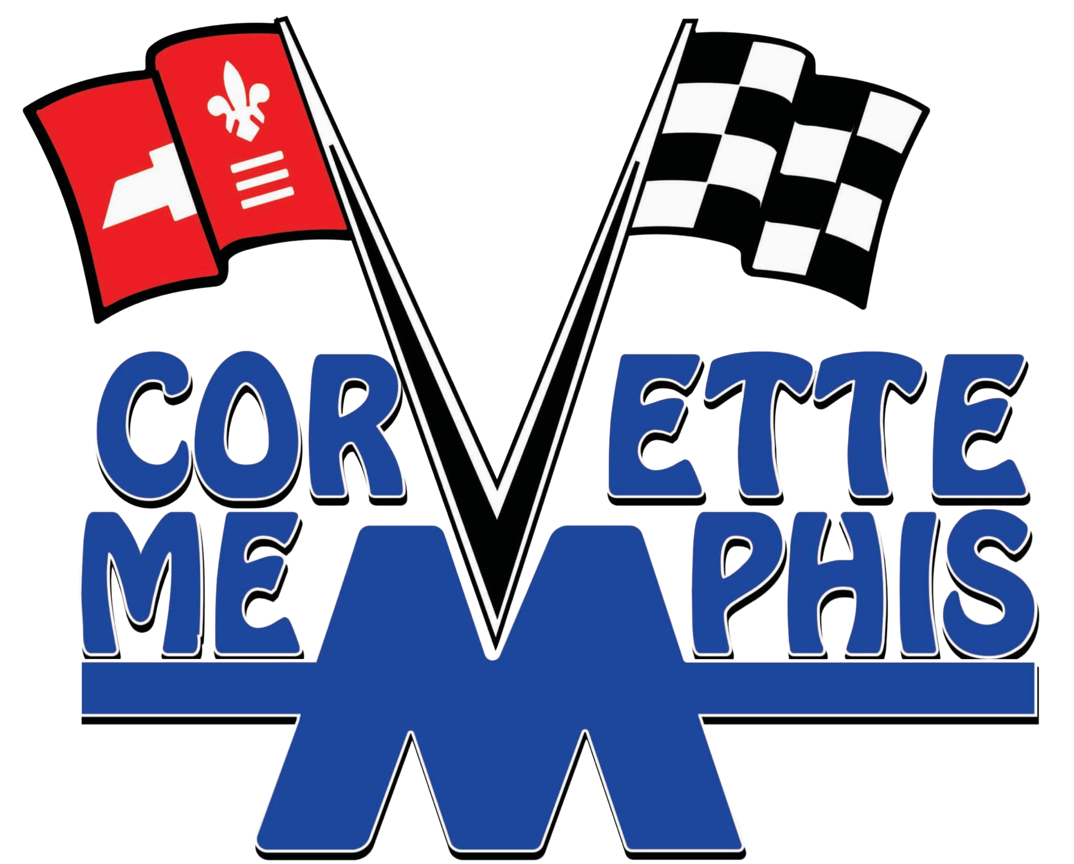
Wendell Cheatam – Treasurer
David Lentz – Secretary
Dave Jacobson – Membership Officer
Bill Ashton – Officer-At-Large
Meeting Location: Collierville Public Library, Second Tuesday, each month.

Greetings Corvette Memphis Members,
Corvette Memphis held their May 2026 meeting May 12. There were 25 members, 2 club guests and 10 members from the Beale Street Corvette Association present.
The Beale Street Corvette Association presented Corvette Memphis with a $500.00 check and a plaque to show their appreciation for members of Corvette Memphis judging the Show Your Ride car show which was held on April 25th. Corvette Memphis members have been judging this show for the past 11 years. The $500.00 will be donated to a Corvette Memphis charity. The past couple of years Corvette Memphis has donated funds to the Carl Perkins Center. The Carl Perkins Center works with abused or neglected children. As a side note of interest, several of the Corvette Memphis Vettes received trophies at the show. No, they did not judge their own cars! Members of the ICCC judged the Corvette Memphis cars. Bravo to the club members who participated this year.
May 9th several members of the Corvette Memphis Club journeyed to the far ends of the earth to attend the 50th Anniversary Memphis Classic Chevy car show in Bartlett, TN. Several of the club members came away with trophies. These were not, "participation trophies“. Memphis Classic Chevy club revamped their show this year and judged cars differently from the past. Fewer awards were handed out this year, so car owners who received an award this year do have bragging rights. There were 138 cars in attendance
A small contingent of Corvette Memphis club members took a road trip to Woodlawn Plantation in LaGrange, TN on May 9th to attend the 2nd annual Woodlawn Plantation Car Show. This show was planned for earlier in the year but got rained out and it was rescheduled. The plantation house was built around 1832 and sits on about 300 acres. The house was used as a Union hospital during the Civil War. It also served as General Sherman’s headquarters. Tours of the house were led by Lisa Juneau. Some of the furniture was built just for this house and the original bed that General Sherman slept in is still in the house. It was like walking through a museum. The house sits on a high bluff over looking the farm land both in front and at the rear of the house. The land seems to stretch on for ever. The guest house served as the cookhouse in the 1800‘s. It now serves as a guesthouse. It has been refurbished and it looks like something out of Southern Living magazine. The ladies really liked the professional stove/oven. It was gas and had like ten controls across the front to run the stove top burners and ovens. This plantation is a working alpaca and horse farm. There was a food truck on site serving some of the best Cajun food around. A band played on the patio. There was a nice cool breeze coming up the bluff all day. There was a lot of history and everyone had a good time. There was a large fireworks display that night.
Corvette Memphis had two former members rejoin the club. Please welcome back Lisa Juneau and Pravin “PJ“ Thakkar. The club is awaiting the applications from two more interested Vette people.
Please visit the Corvette Memphis website (www.corvettememphisinc.com) and click on the Events button. There are more events and cars n coffee meetups to shake a checked flag at coming up in the next few weeks and months.
Thanks Marla and Gary for your leadership and finding events to keep the members engaged.
I am going to wrap this up now because the song “Rambling Man“ is beginning to play in my head.

Until next month or the next show or cars and coffee.
Save the Wave.
Bill Ashton, Member-At-Large

