Corvette Memphis
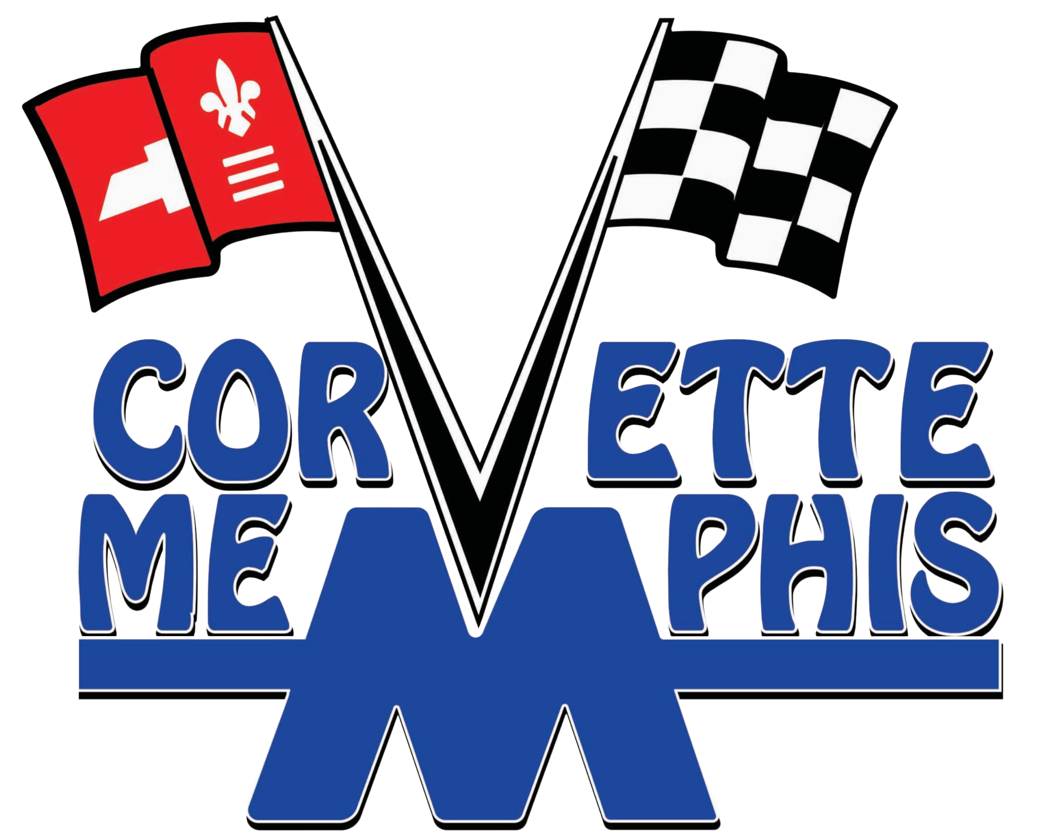
March 10, 2026 Club Meeting

Gary Keirce – President
Marla Giddens – Vice-President
Wendell Cheatam – Treasurer
David Lentz – Secretary
Dave Jacobson – Membership Officer
Bill Ashton – Officer-At-Large
Meeting Location: Collierville Public Library, Second Tuesday, each month.

It was good to get back to our monthly club meeting after missing February meeting. We had our annual Valentine Dinner in February and cancelled our regular meeting.
There was a lot to cover since our January meeting. Gary presented a great slideshow from our Valentine Dinner at Grisanti’s and Cars and Coffee gathering at GPAC. There are several car shows and the Corvette Bash in Bowling Green KY coming up in the next months. Corvette Memphis will be judging the Show Your Ride Corvette Show on Beale St. next month. Gary is still looking for some help with the judging. Our club has judged this show for the last 10 or 11 years. If you would like to judge, please reach out to Gary.
There was interest expressed about making a trip this spring to the Full Throttle Distillery in Trimble, TN. Gary said he would call his contact at the distillery to see about setting up a trip. If you are interested in going and loading up on Moonshine, reach out to Gary.
We had 25 members and two guests for our meeting. Sean Williams joined the club tonight. Sean owns a 1961 C1 Corvette resto mod. The car sounds amazing.
Dave Jacobson received a club application from Guy Mauro last Saturday at Cars and Coffee GPAC. Guy decided to join Corvette Memphis and owns a 2023 C8 ceramic gray Stingray. Guy was a manager at Keras Subaru on Hack Cross and hosted Cars and Coffee event at Keras in 2023. Guy is now retired.
Welcome to our new members.
To see a list of the up-coming shows and Cars and Coffee schedule please go to our website. Gary has put in a lot of work keeping our website up to date.
Save the Wave,
Bill Ashton, Member-At-Large

