Cars n Coffee
1st Saturday of the month
Edelbrock HQ 8649 Hacks Cross Rd
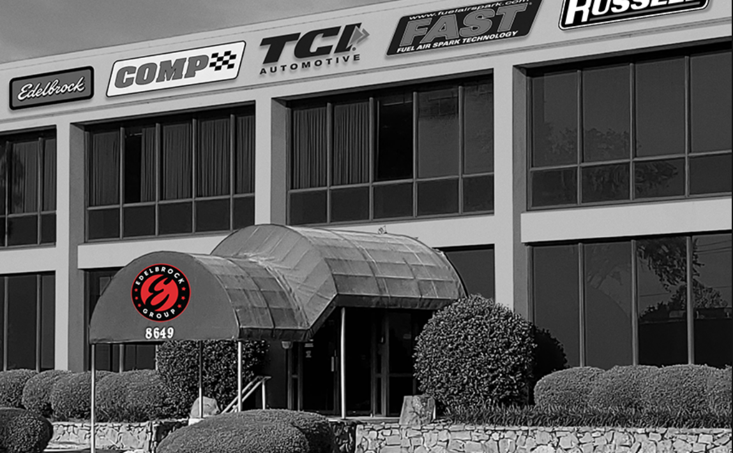
Olive Branch MS 9-11am
3rd Saturday of the month
NAPA Auto Parts 7415 US Hwy 64
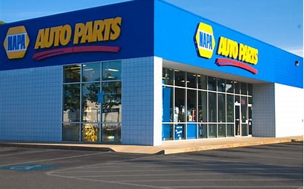
Memphis TN 9-11am or
Byhalia Brunswick St & Church St
Byhalia MS 9-11am
4th Saturday of the month
Germantown Performing Arts Center
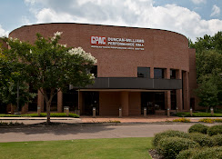
1801 Exeter Rd Germantown TN
8-10am

