Corvette Memphis
Valentine’s Dinner for 2026
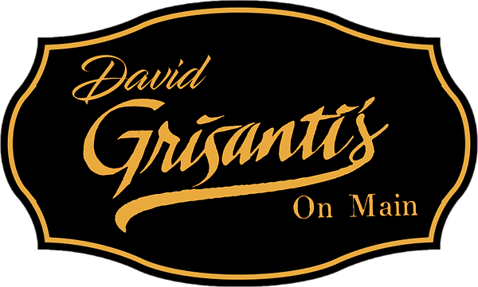
At David Grisanti’s on Main, we are proud to continue the Grisanti family legacy. One rooted in passion, tradition, and authentic Italian cuisine. We invite you to savor the flavors of Italy, prepared with the same love and dedication that has defined the Grisanti name for generations.

OUR HISTORY

It all began in Lucca, Italy
The Grisanti Family has had many successful restaurants in the Memphis area since David’s grandfather, Rinaldo, immigrated from Lucca, Italy as a young man and opened the first market in 1909. As the youngest son of Big John Grisanti, David grew up in the Original Grisanti’s Restaurant on Airways and Lamar, where he developed a passion for fine Italian cuisine. For the last five years, David has been operating his restaurant in Sheffield Antique Mall and developing a bond with the customers in Collierville. In 2023 an opportunity presented itself for David to move his restaurant to Collierville town square and continue to fill the need for a Grisanti’s restaurant in the Collierville area.

Thursday, February 12, 2026
Reservation at 7:00pm, Arrive 6:45pm
RSVP to Marla Giddens by 1/31/2026
Address
148 North Main Street,
Collierville, TN

