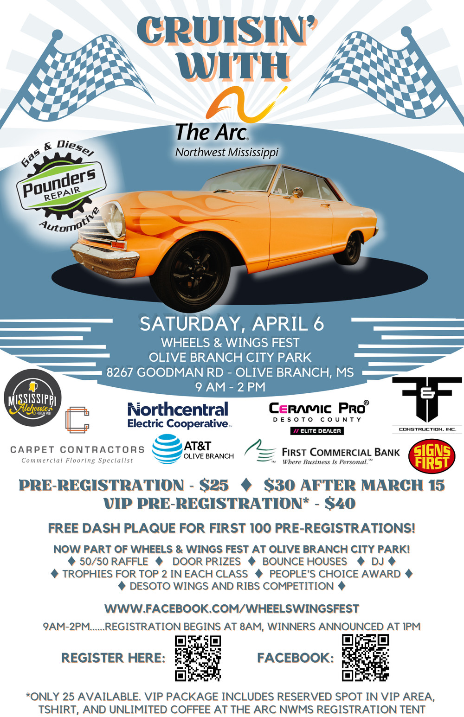

To use link hold CONTROL + click on link

<https://thearcnwms.org/cruisin-with-the-arc-car-show>

