Corvette Memphis
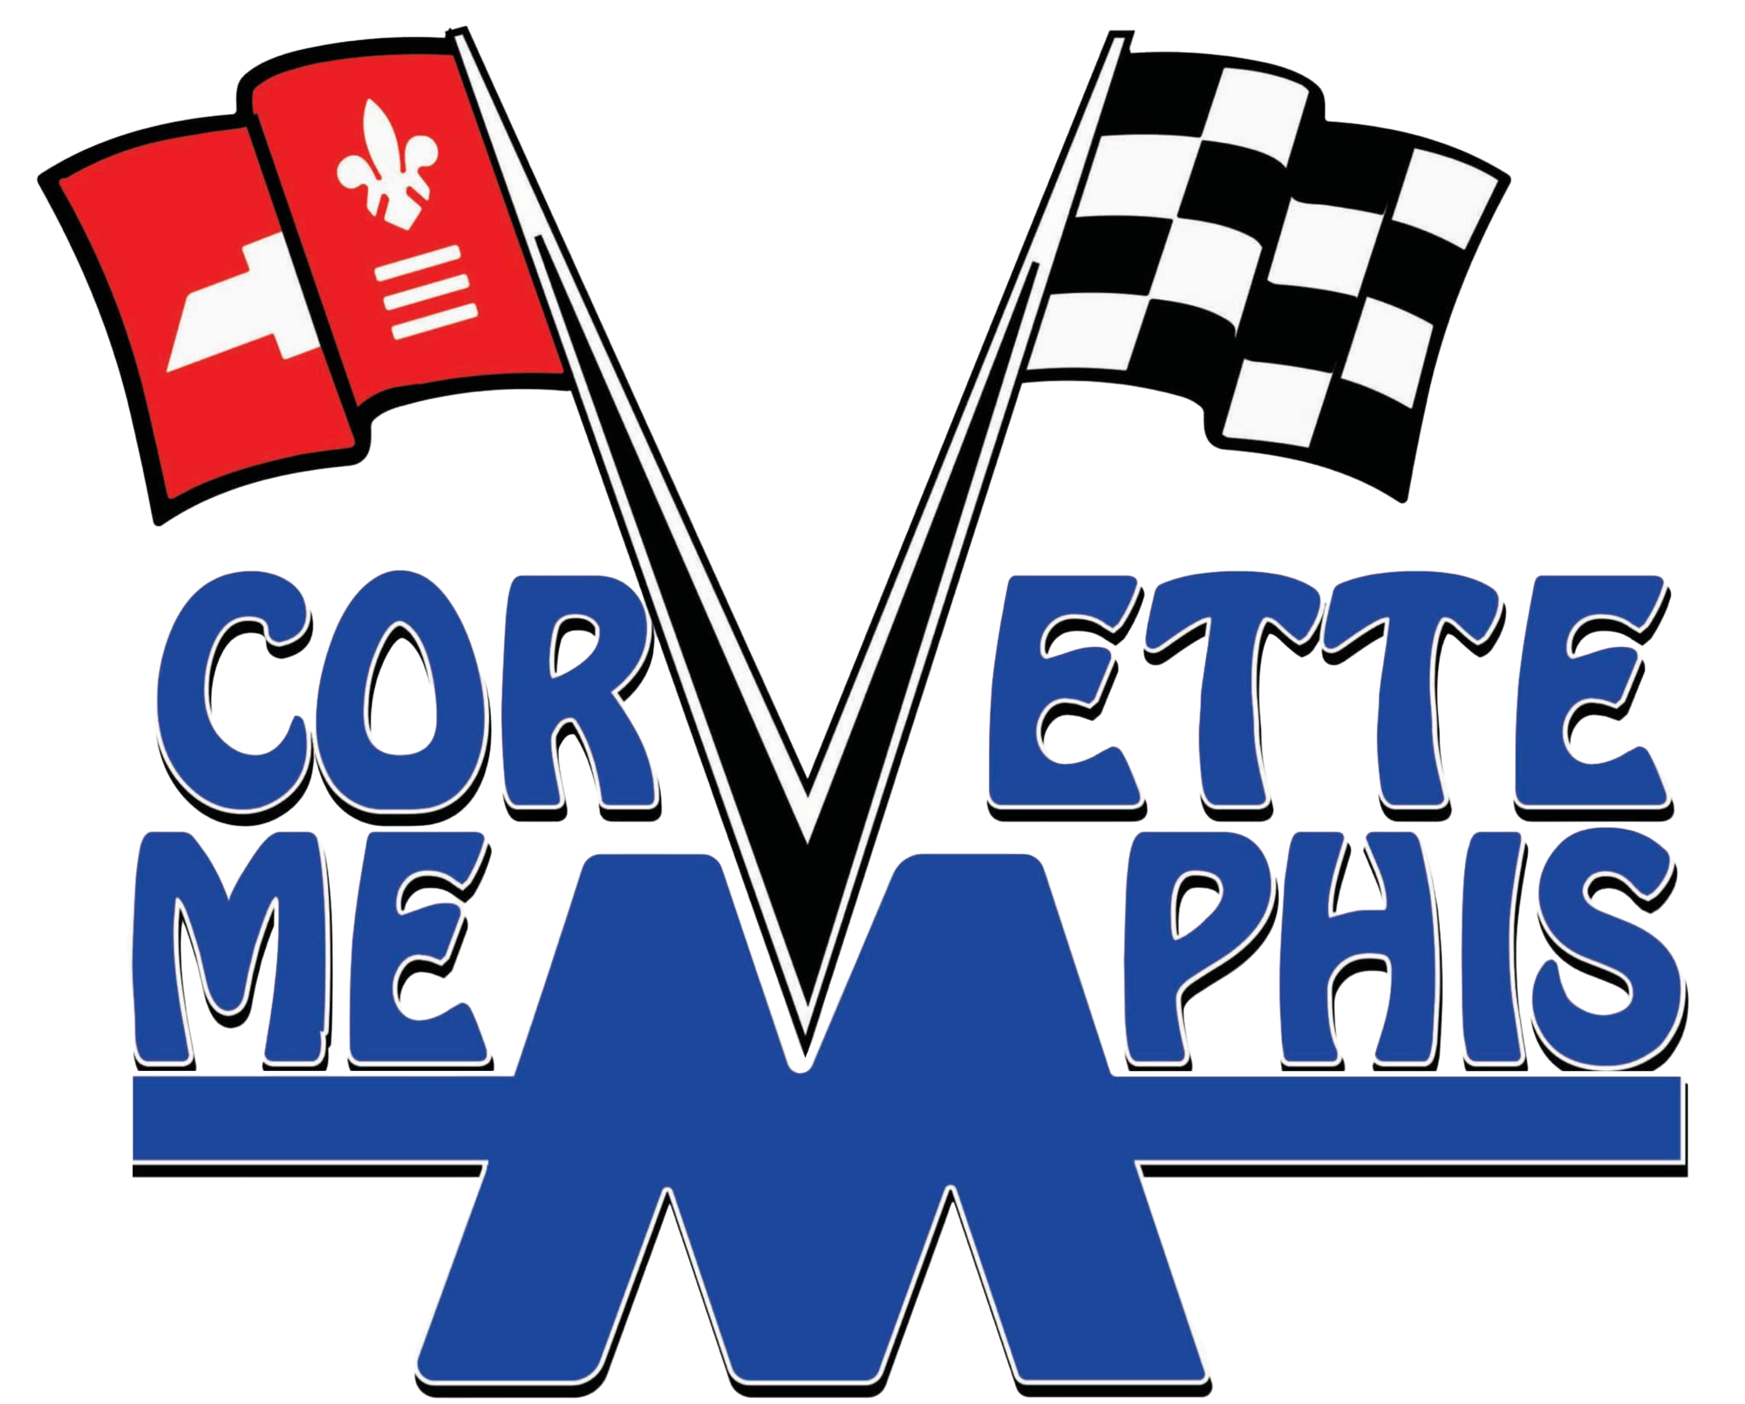
July 2026 Club Meeting

Gary Keirce – President
Marla Giddens – Vice-President
Wendell Cheatam – Treasurer
David Lentz – Secretary
Dave Jacobson – Membership Officer
Bill Ashton – Member-At-Large
Meeting Location: Collierville Public Library, Second Tuesday, each month.

Greetings Corvette Memphis Club Members,
I am back from vacation and back to our monthly newsletter.
There were 22 club members and one visitor at our meeting this month. We welcomed our two newest members, Anthony and Amanda Wood. They own a 2023 70th Anniversary Edition convertible in carbon flash metallic. They joined at the Jimmy Gray Cars and Coffee. It was said that Mr. Gray was very excited about hosting the Cars and Coffee at his dealership, after he sold two pickup trucks during the event. A win-win for everyone.
Ok race fans, Dave Lentz is organizing another legendary road trip. This time to East Tennessee. Rumor has it there is a curvy road out that way known as the Tail of the Dragon. The dates are August 12 thru 15. All the details are posted at our new and improved website, thanks Gary. Please contact Dave to let him know that you would like to go. During the meeting Dave made a plea to the women in the club to come on the trip.
Gary mentioned the Go Cat Go charity car show coming up on September 5 at Living Hope Church in Piperton. This show benefits the Carl Perkins Center. This is a charity that our club has adopted. So grab your chairs, load up that beautiful Vette and come on out for a good cause. All the details about pre-registering and times can be found on our website.
The annual Collierville Car show is coming up on September 26, 8:00 am till noon. This is another event that our club has been involved in for years. Our members volunteer to help park cars for the show. Again there is a flyer on our website with all the details. Please come help us get event cars parked at Collierville Central Church on Winchester Blvd – be there at 7:15am
If you have not noticed, I am pushing the website. Gary has done a fantastic job with the website. Go have a look at the Events section to get all the details of upcoming events. Browse around the website and look at the pictures. Gary is planning on adding more pictures and features. www.corvettememphisinc.com
After the meeting several members of the club went to dinner at Maeve’s Tavern on the Collierville Square. The food was great and there were a lot of lively conversations. Good times.
Until next month or the next cars and coffee, Save the Wave.
Bill Ashton, Member at Large

