Corvette Memphis
Meeting April 2026 Club
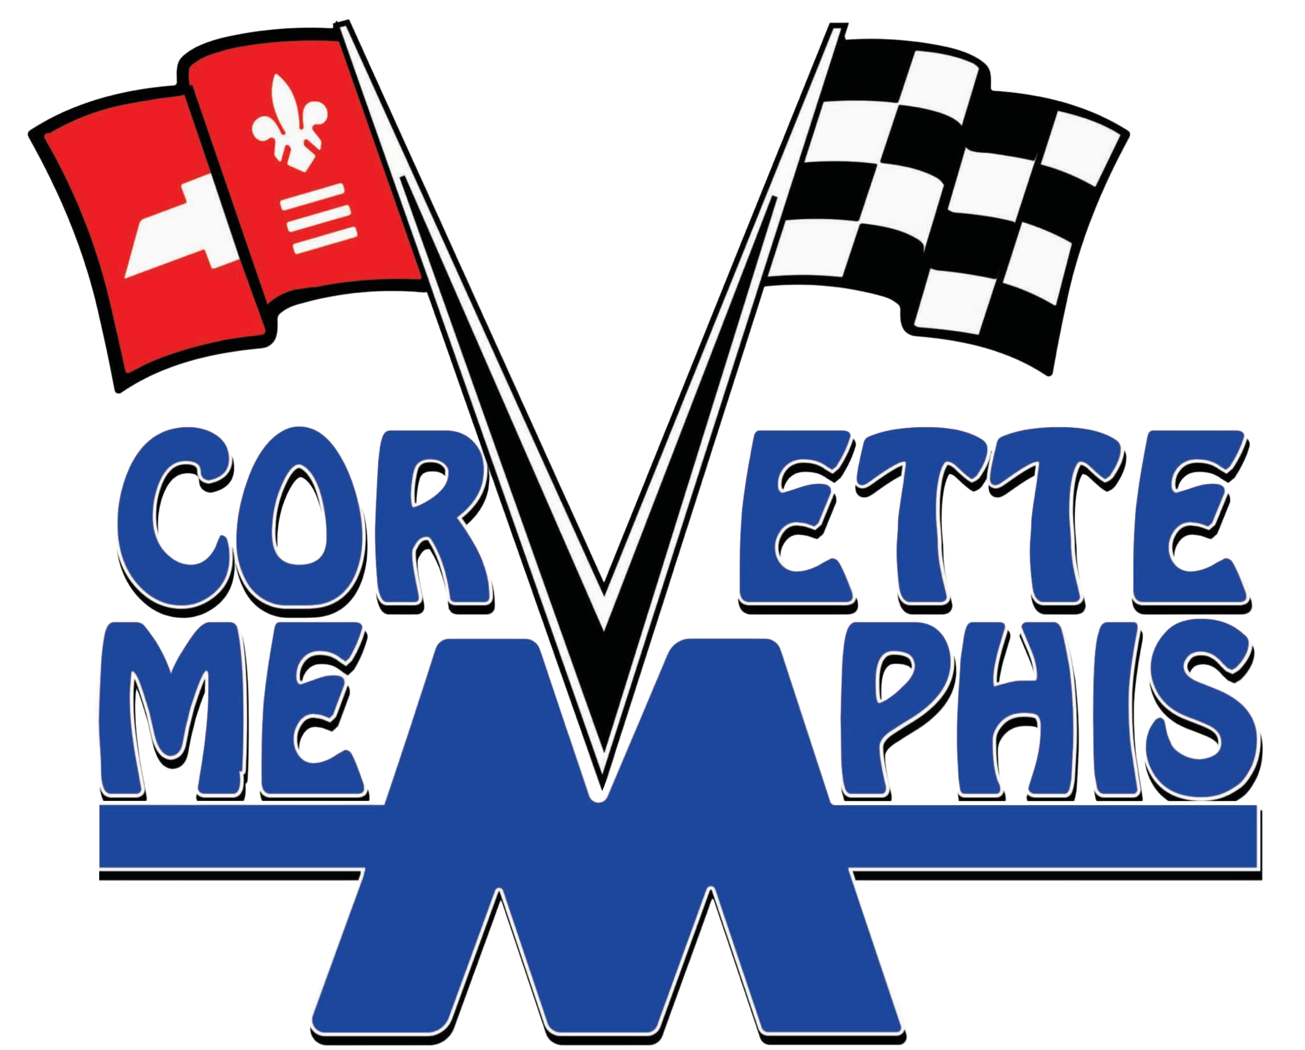

Gary Keirce – President
Marla Giddens – Vice-President
Wendell Cheatam – Treasurer
David Lentz – Secretary
Dave Jacobson – Membership Officer
Bill Ashton – Officer-At-Large
Meeting Location: Collierville Public Library, Second Tuesday, each month.
Greetings Corvette Memphis Members
We held our April club meeting on April 14, 2026. There were 24 members present and we had two visitors. Some of you will remember Lisa Juneau. Lisa came to the meeting and is thinking about rejoining the club. Lisa has a C6 Corvette. Bob Mancini also visited the meeting, he drives a 2022 Red Mist convertible.
Gary Keirce got a new 2026 E-Ray, Sebring Orange, and it is a beauty. Kevin Gray came back into the fold, he traded in his LT1 Camero for a new Z06 Corvette. It is a black beauty, the USLEDGEND is back. Congratulations guys on your new rides.
On Saturday, April 11, 2026, twelve club members gathered for the 3rd annual charity car show at Edelbrock in Olive Branch. The proceeds from the show go to little Charlotte’s family to help with her medical needs. Charlotte is 3 years old. Charlotte received a heart transplant soon after her birth and has been receiving medical assistance ever since. She is doing great and we look forward to seeing her again next year for the car show. Charlotte is the daughter of one of the Edelbrock employees. Bill posted a short video from the car show at his Youtube channel, @williamashton6558.
There is a long list of coming events and car shows, and Gary has posted them to our website. Go to the new and improved (thanks Gary) website to see the list of shows and events.
I know we were all disappointed when the car show at the Woodlawn Plantation in LaGrange, TN was canceled a few weeks back because of the weather. Good news, a new date for the car show has been announced. The new date is May 9, 2026. This date is the same date as the Classic Chevy Car Show in Bartlett, TN. These are two great options. Shine up your cars and get out there and show them off.
After the meeting, the club motored over to the Commissary BBQ restaurant for some good ole Memphis style Que.
Your wives are encouraged to attend the club meetings as well. The wives who attend the meetings would love to meet and mingle with the other wives. Make it a date night and take them to dinner after the meeting.
Until next month or the next show or cars and coffee.
Save the wave.
Bill Ashton, Member-At-Large

