Wed, Jan 14 at 7:42 PM
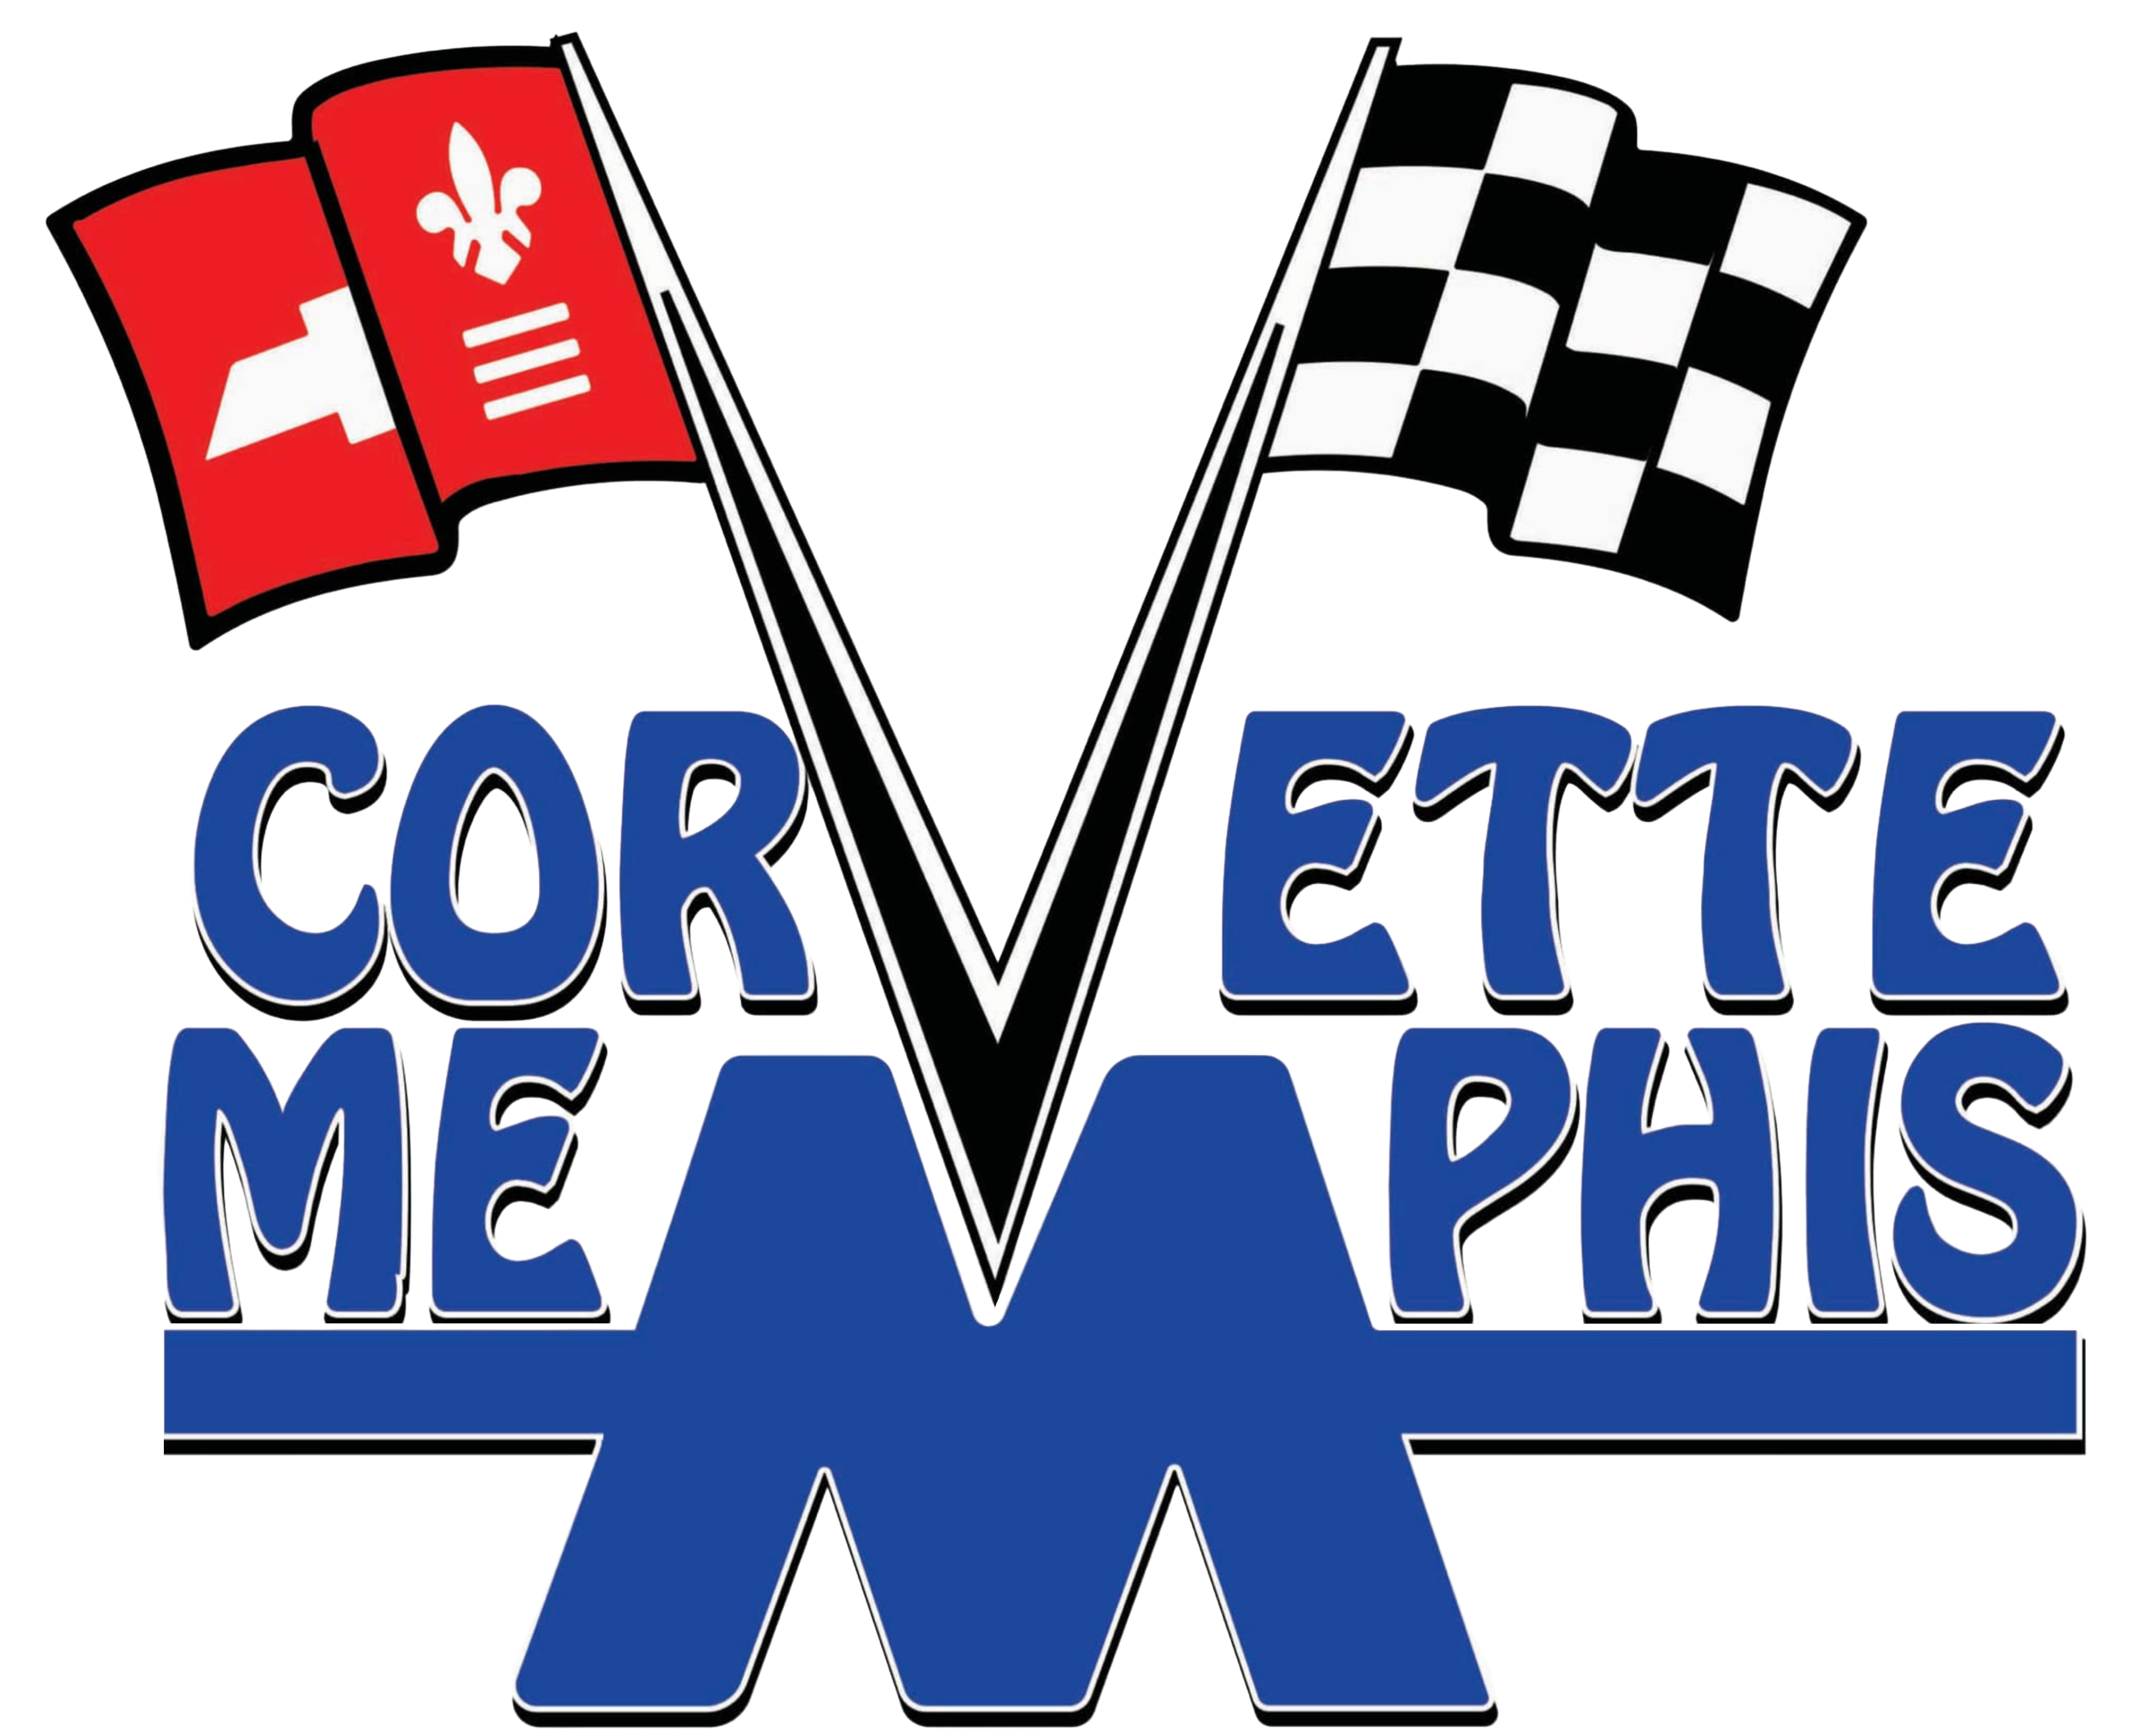
Corvette Memphis
January 2026 Club Meeting
Gary Keirce – President
Marla Giddens – Vice-President
Wendell Cheatam – Treasurer
David Lentz – Secretary
Dave Jacobson – Membership Officer
Bill Ashton – Officer-At-Large
Meeting Location: Collierville Public Library, Second Tuesday, each month.

This first club meeting of the new year was presided over by our newly elected club president, Gary Keirce. Our newly elected board members, Marla Giddens, Vice-President, Dave Jacobson, Membership Officer, Bill Ashton, Officer-At-Large, and David Lentz Secretary were present. Garth Reid greeted the members as they arrived and had them sign in. This is a new procedure to have a record of those attending the meetings. We had thirty members for our first club meeting of the year.
Gary has done an extensive overhaul of our web page. He worked very hard to bring new life to the web page. Gary said that he did not have any experience with working on web pages before he started working on it, but he was determined to learn the ins and outs on how it worked. Gary redesigned the homepage, and it looks good. Gary has added a quarterly calendar that will have upcoming club events. Under the Events tab there will be Cars and Coffee locations and dates. Gary wants to update the Repairs tab with shops and venders that provide excellent service and products. If you have someone that you use and recommend, please email Gary that information and he will add it to the website. When you have time, please visit the website and go through the tabs. I think you will agree that Gary did a good job. The new password for the website is CorvetteClub, chuck has left the building after many years.
There will not be a February club meeting. We will be doing our annual Valentines Club Dinner on February 12th at David Grisanti’s, 148 North Main Street, Collierville, TN. Our reservation time is 7:15 pm. If you did not sign-up at our club meeting, you can email Marla Giddens at moneycoachmarla@gmail.com to RSVP. You need to RSVP before January 30th.
If you were at our Christmas Party in December, go to our website and enjoy the members photos Gary took.
Hope to see you all at the Valentines Dinner and our next club meeting in March.
Save the Wave,
Bill Ashton, Member-At-Large

